**EVACUATION PROCEDURE IN THE EVENT OF A FIRE OR OTHER EMERGENCY**

Upon the discovery of a fire, or if the fire alarm operates or if there is any other emergency:-

All staff, long term visitors and students at induction have details shared with them relating to fire safety, including information as to where to find specific room evacuation advice.

**ASSEMBLY POINT – CAR PARK LOCATED AT THE BACK OF THE BUILDING**

On discovering a fire:

1. Staff and team leaders must CALMLY raise the alarm by shouting and breaking the alarm glass.
2. Immediately evacuate the building following set procedure.
3. Using the nearest, safest exit lead the students out and congregate at the marked assembly point.
4. Anyone with special needs must given assistance to vacate the building.
5. Manager or duty manager to check all rooms, toilets, corners, etc.
6. Close all doors behind you.
7. **DO NOT re-enter the building until the fire brigade say it is safe to do so.**

The Manager is to:

1. Pick up the sign in register, emergency contacts list, mobile phone and visitor book
2. Telephone emergency services: dial 999 and ask for the fire service
3. Go to the FIRE ASSEMBLY POINT - safe place clear of the building - check the students against the register
4. Account for all adults. The manager **must** assume that **ANYONE** not at the assembly point are still in the building.

* **Do not try to collect personal belongings on evacuating the building.**
* **Do not attempt to go back in and fight the fire.**
* **Do not attempt to go back in if any students or adults are not accounted for.**
* **Advise the fire services of anyone missing.**

**FIRE EMERGENCY ACTION PLAN**

Name of company: Positive Progress Tuition

Address: 41a Mill Lane, West Derby, Liverpool, L12 7HZ

Date: 23/10/2020

**Action to be taken by the person discovering a fire**

On discovery of a fire anywhere in the centre, the first action to be taken by the person discovering the fire is to raise the alarm. This can be done by operating one of the break glass points situated throughout the centre.

**Simply press the centre of the call point to activate the alarm**

Upon hearing the fire alarm, all staff, team leaders, contractors and visitors in the centre must ensure everyone in the centre evacuates the building by using the nearest, safest fire exit and re-group at the fire assembly point located at Barclays Bank.

A number of fire extinguishers are located throughout the centre.

They must only be used by a member of staff, and only if it is safe to do so.

**NOBODY is to place themselves in any danger**

**If staff have not received suitable training, they MUST NOT USE THE FIRE EXTINGUISHERS**

If for any reason a member of staff is not present, then the person discovering the fire becomes the **RESPONSIBLE PERSON**

The RESPONSIBLE PERSON will immediately call 999 requesting the fire brigade. They will clearly state the building address: **41a Mill Lane, West Derby, Liverpool, L12 7HZ**

If known the location of the fire should also be given i.e. fire in the kitchen

If anybody if thought to be trapped inside the building, then the fire brigade should also be informed of that fact, together with any information thought to be relevant or of assistance.

**FIRE EXTINGUISHERS LOCATIONS**

**Ground floor First floor staircase Kitchen**

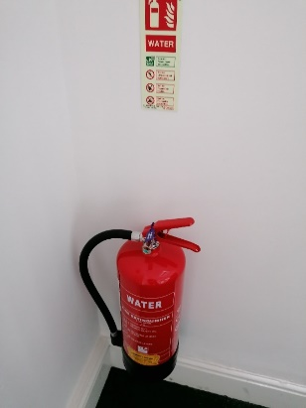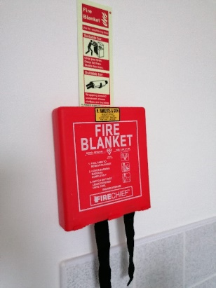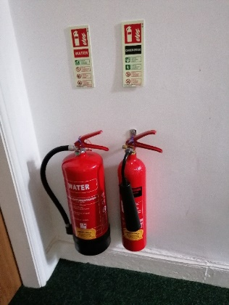

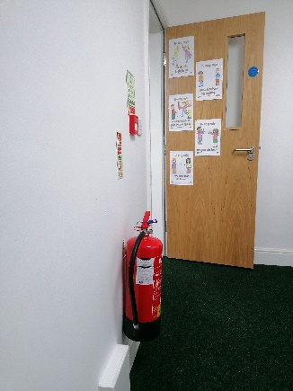**Loft Room**

**PREMISES BUILDING PLAN - *NOTE: Not to scale - Windows Fire equipment***

**Ground Floor First Floor Second Floor**

STAIRS

STAIRS

STAIRS

S

T

O

R

A

G

E

Classroom

Kitchen

Server room

Library

Classroom

Classroom

Office

Toilets

Toilets

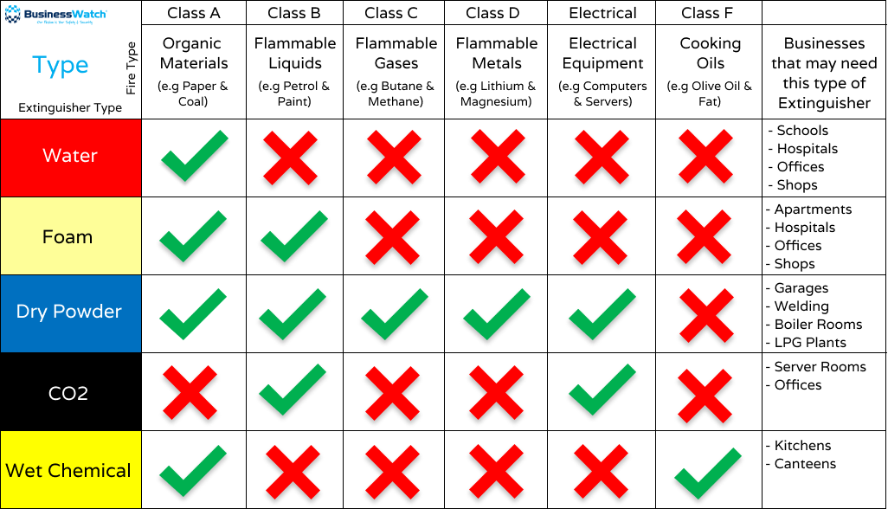

**Fire Evacuation Acknowledgement**

I acknowledge I have read and agree to the follow the procedure as set out in the fire evacuation document.

Print name:

Sign:

Date:

Manager name:

Sign:

Date: